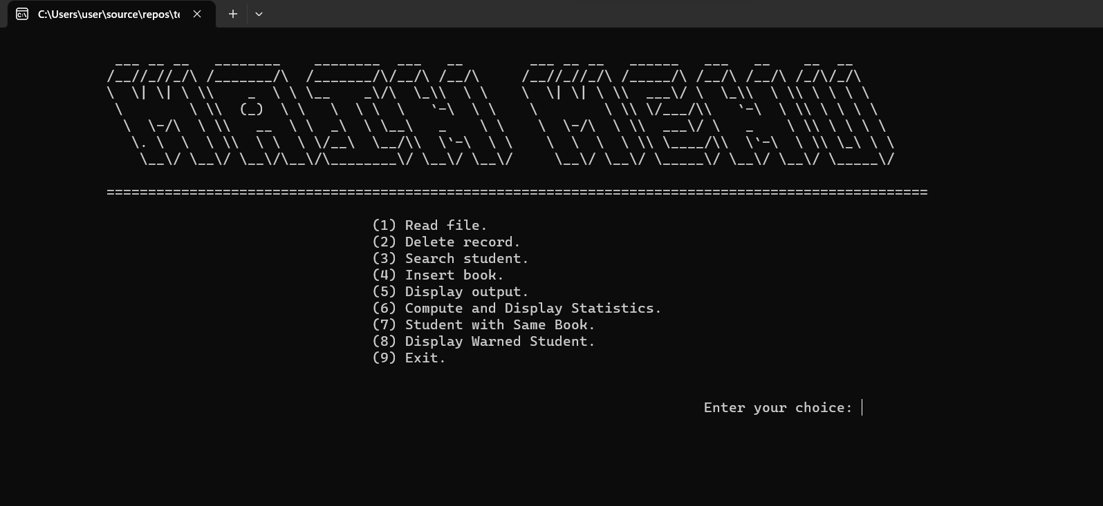  
Menu table

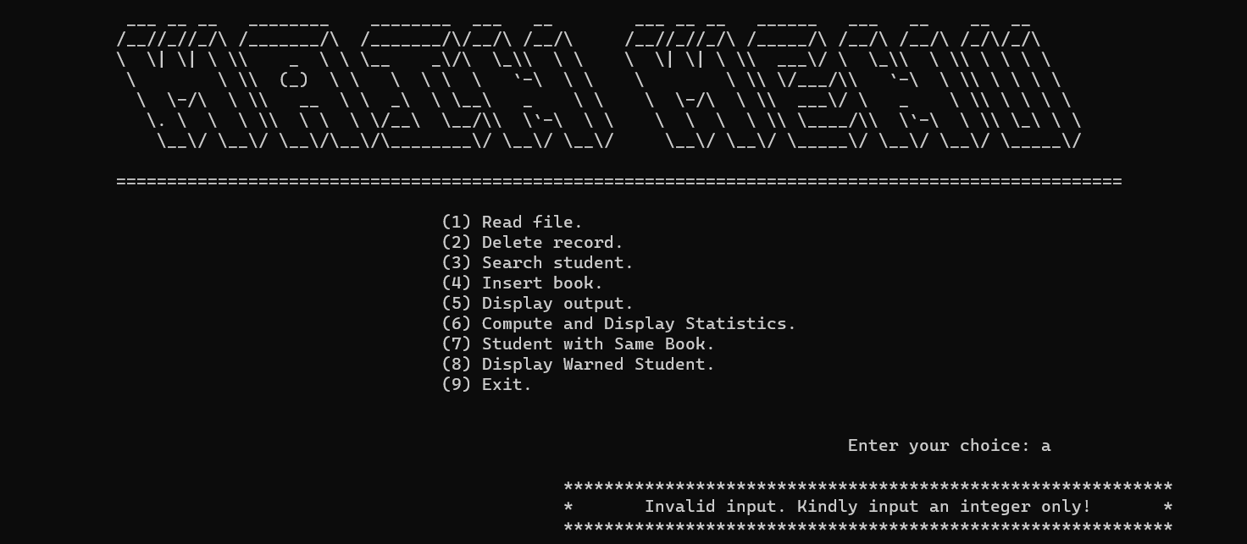  
(if input invalid integer)  
  
  
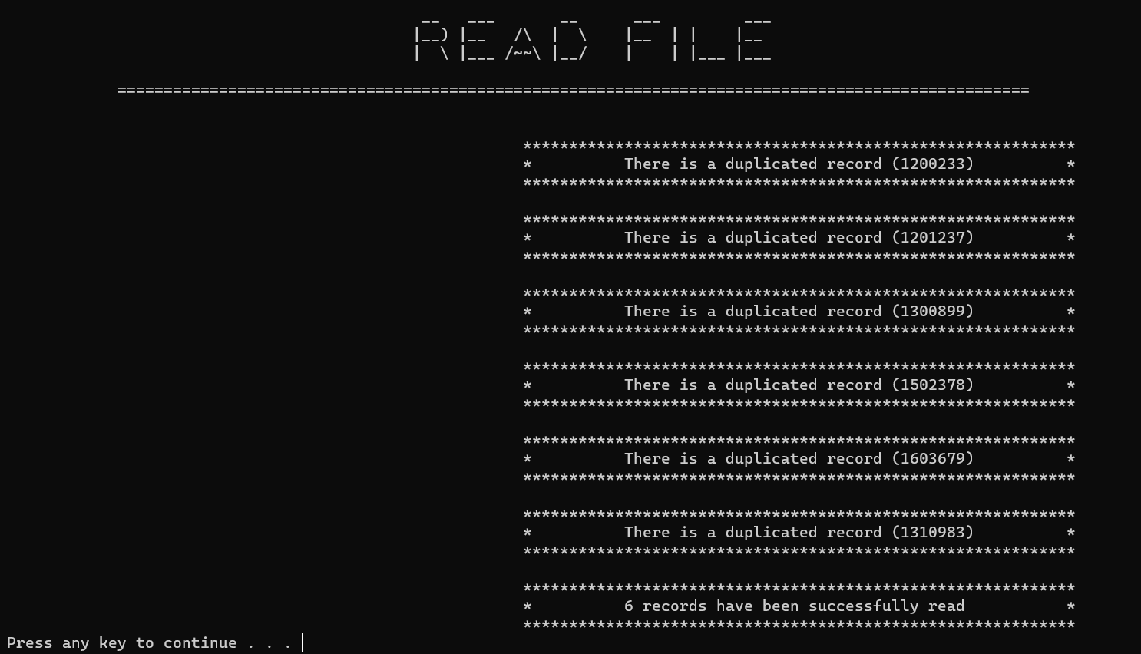  
Function1 duplicaterecord  
  
  
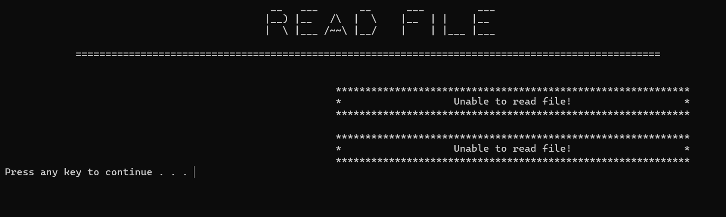  
Function 1 when no file readed  
  
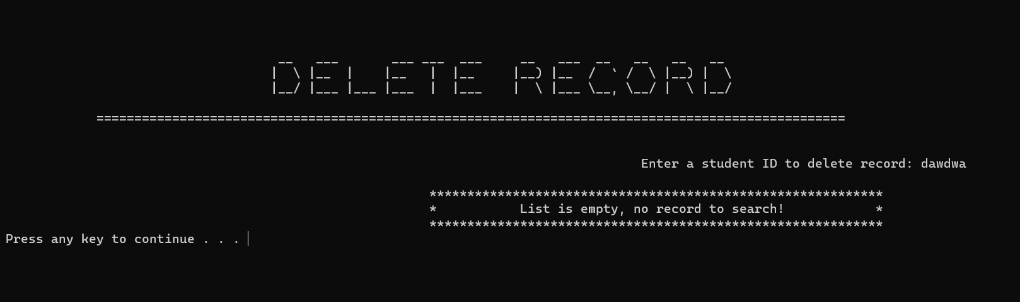  
(function2 invalid input)  
  
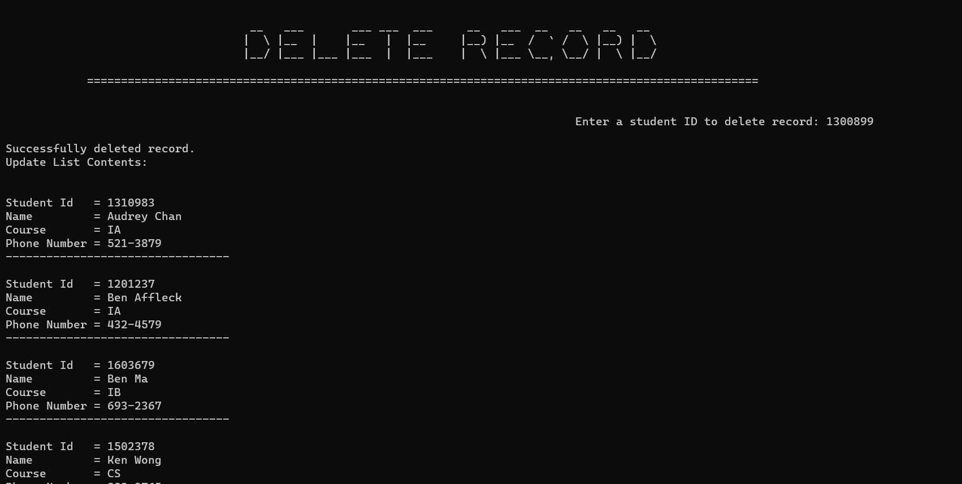

(function2 delete student)

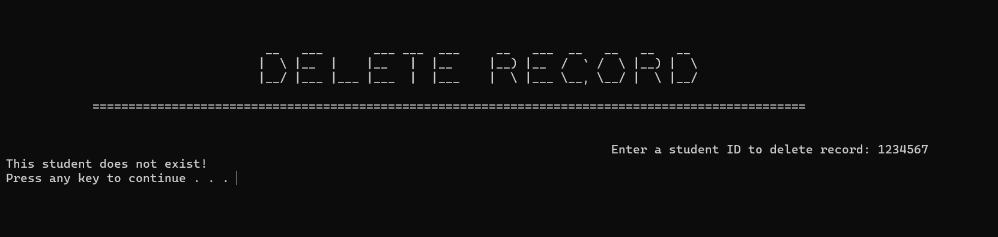

(function2 when no student)

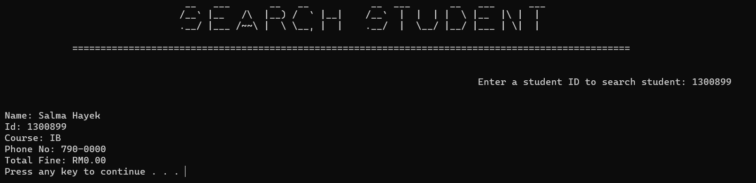

(function3 search student)

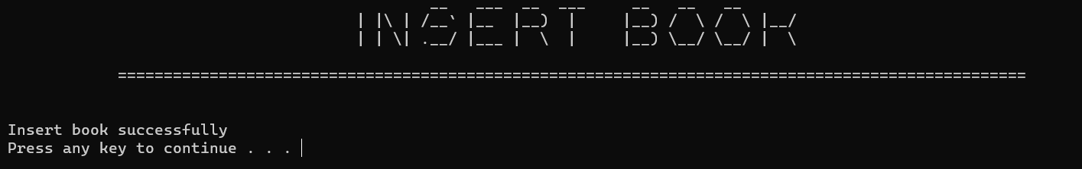

(function4 insertbook)  
  
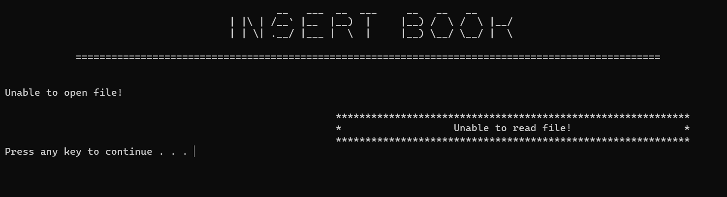

(function4 when no file readed)

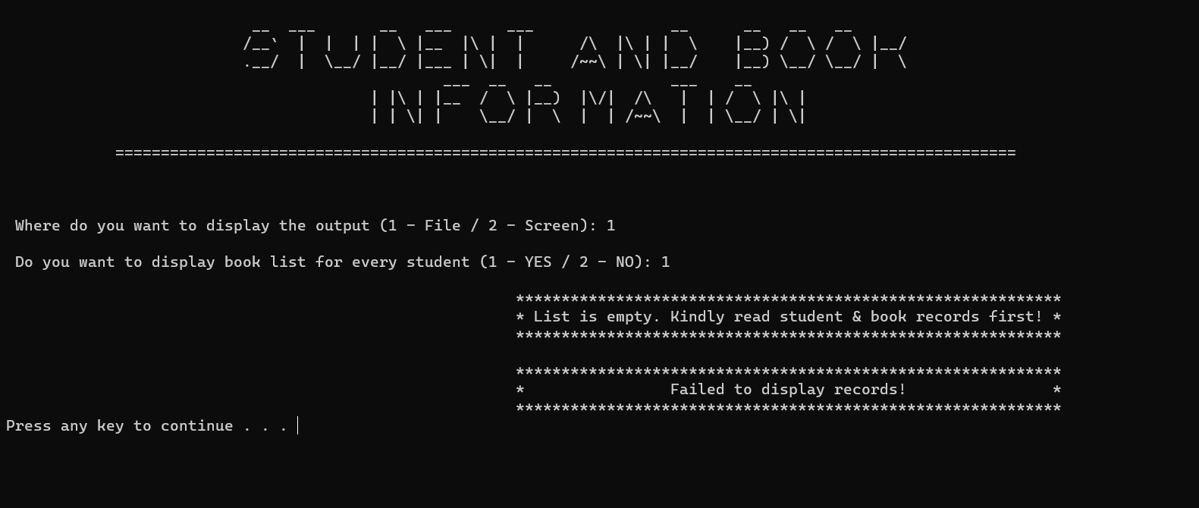

(function5 when list->empty(), same for 1,2 ; 2,1 ;2,2)

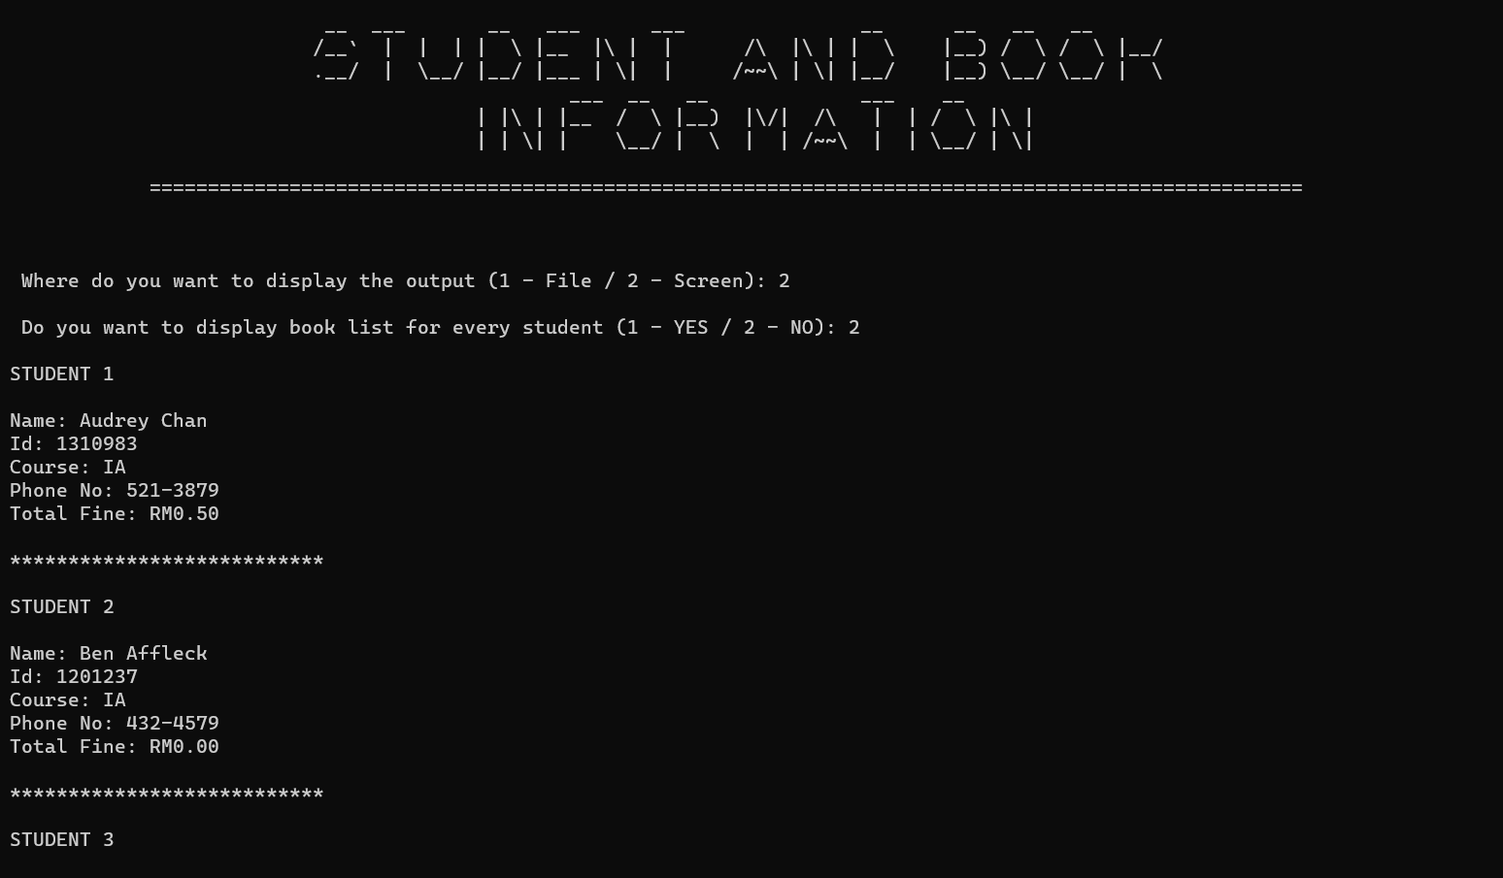

Function 5 for screen, no booklist

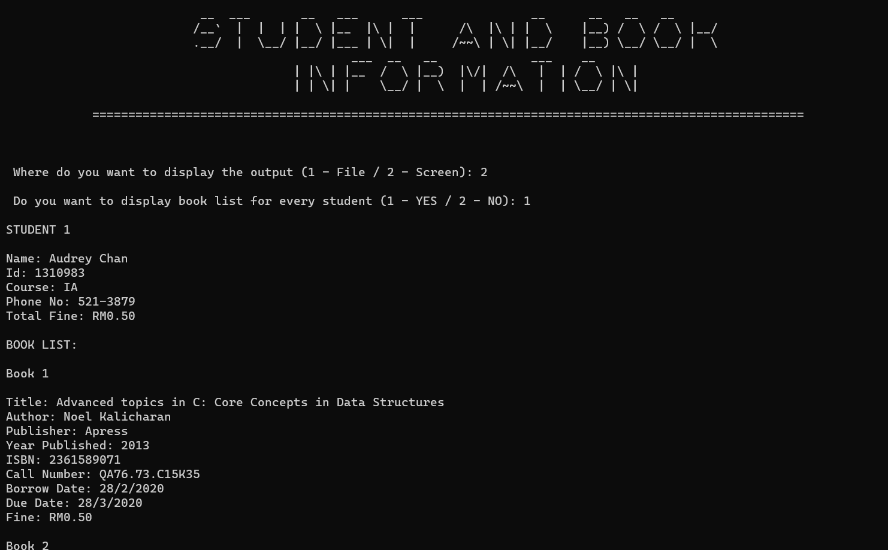

Function5 for screen, include booklist

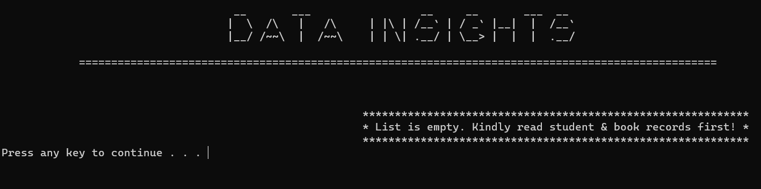

Function6 when list->empty()

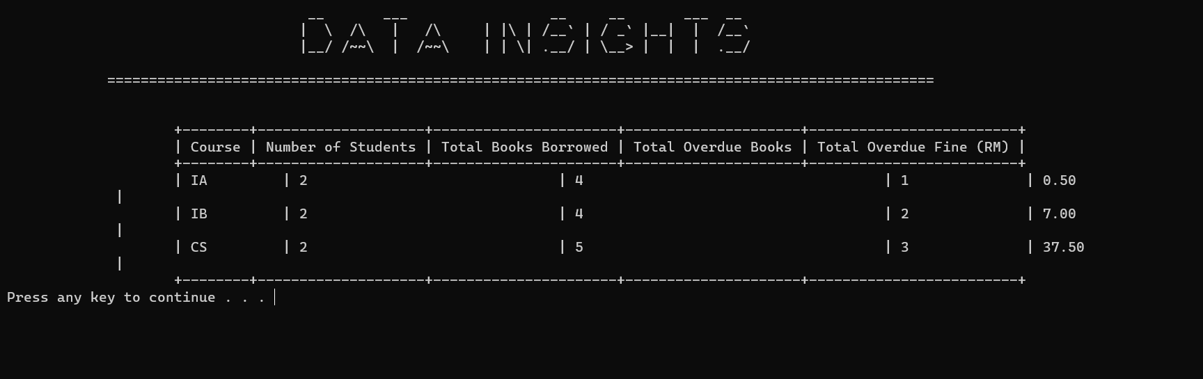

Function6 when readed

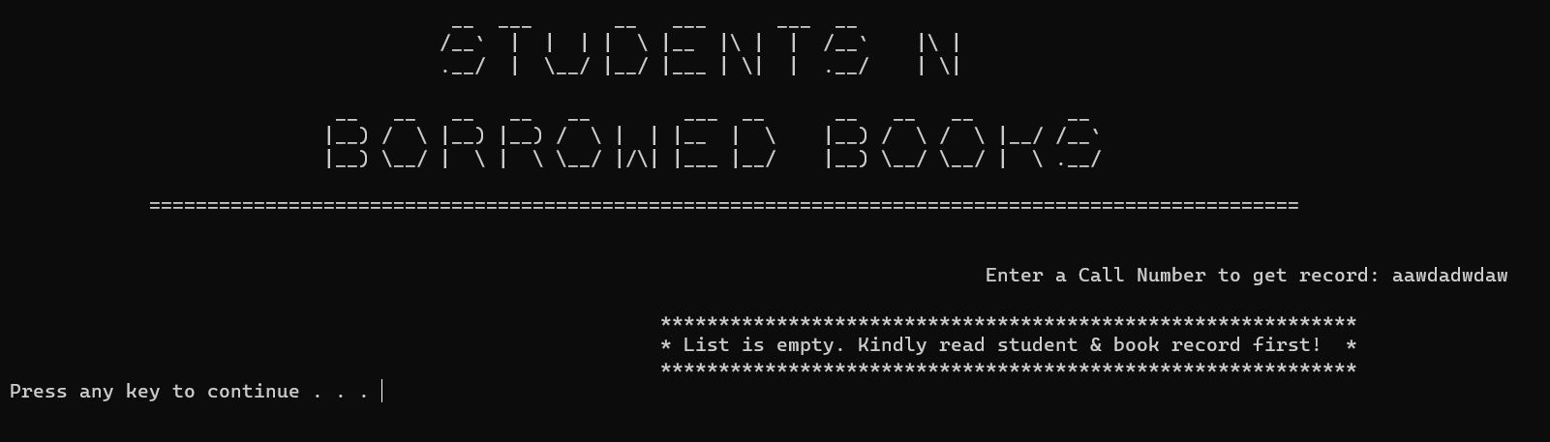

Function7 when list-> empty

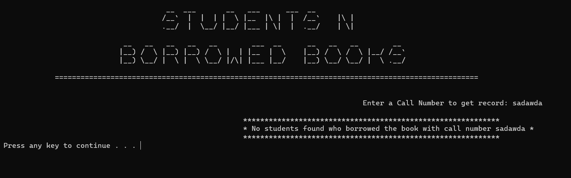

Function7 when invalid input

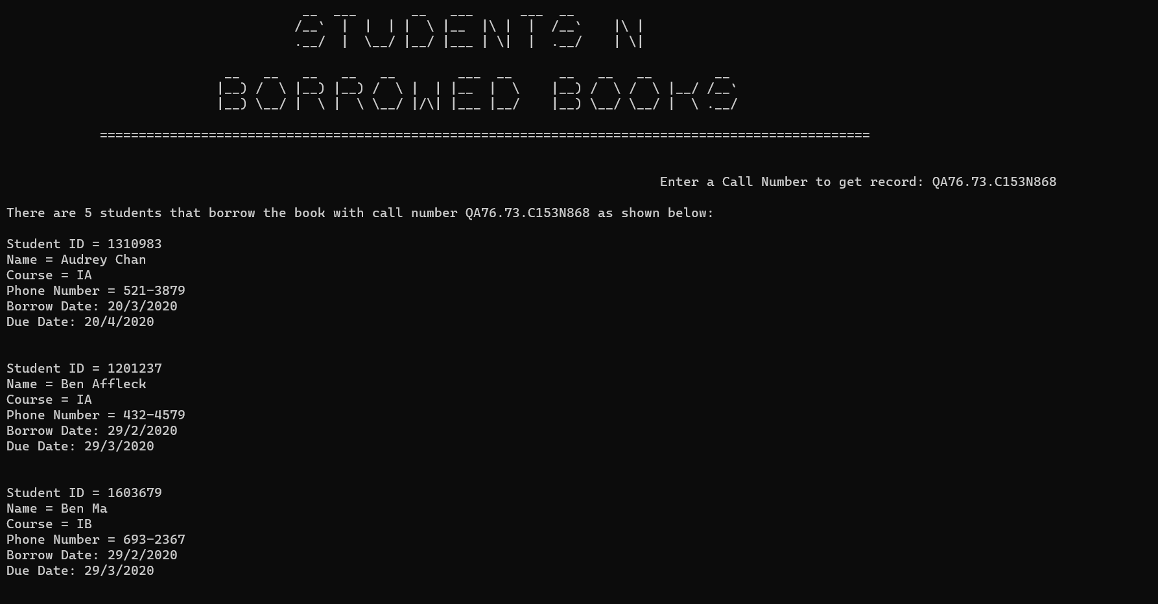

Function7 when successfully display

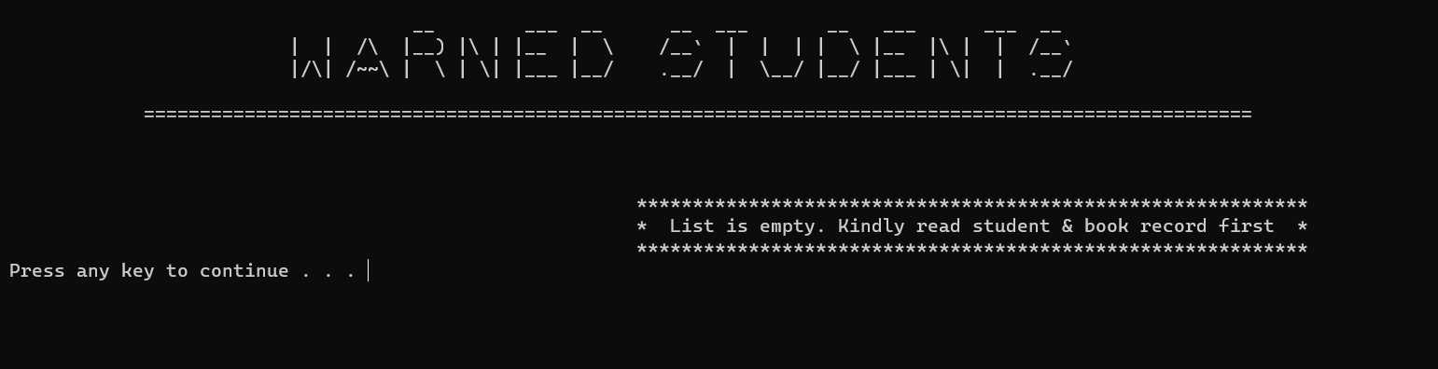

Function 8 when list is empty

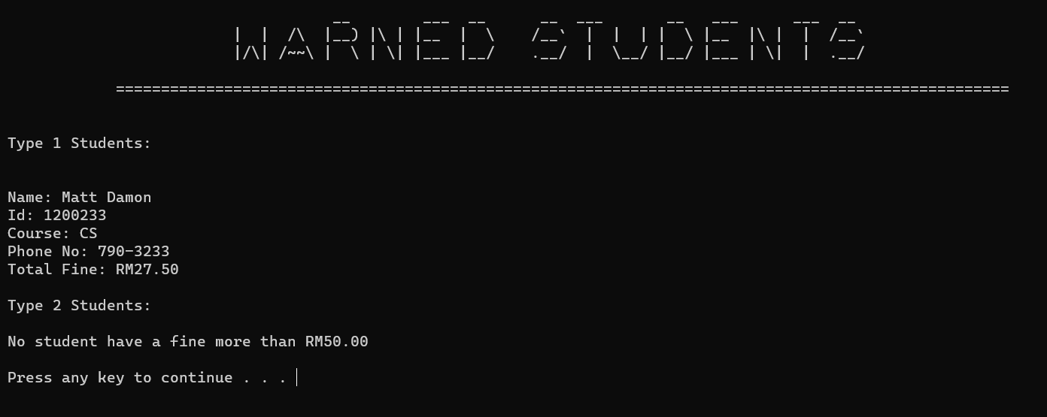

Function8 when successfully read